GUI:
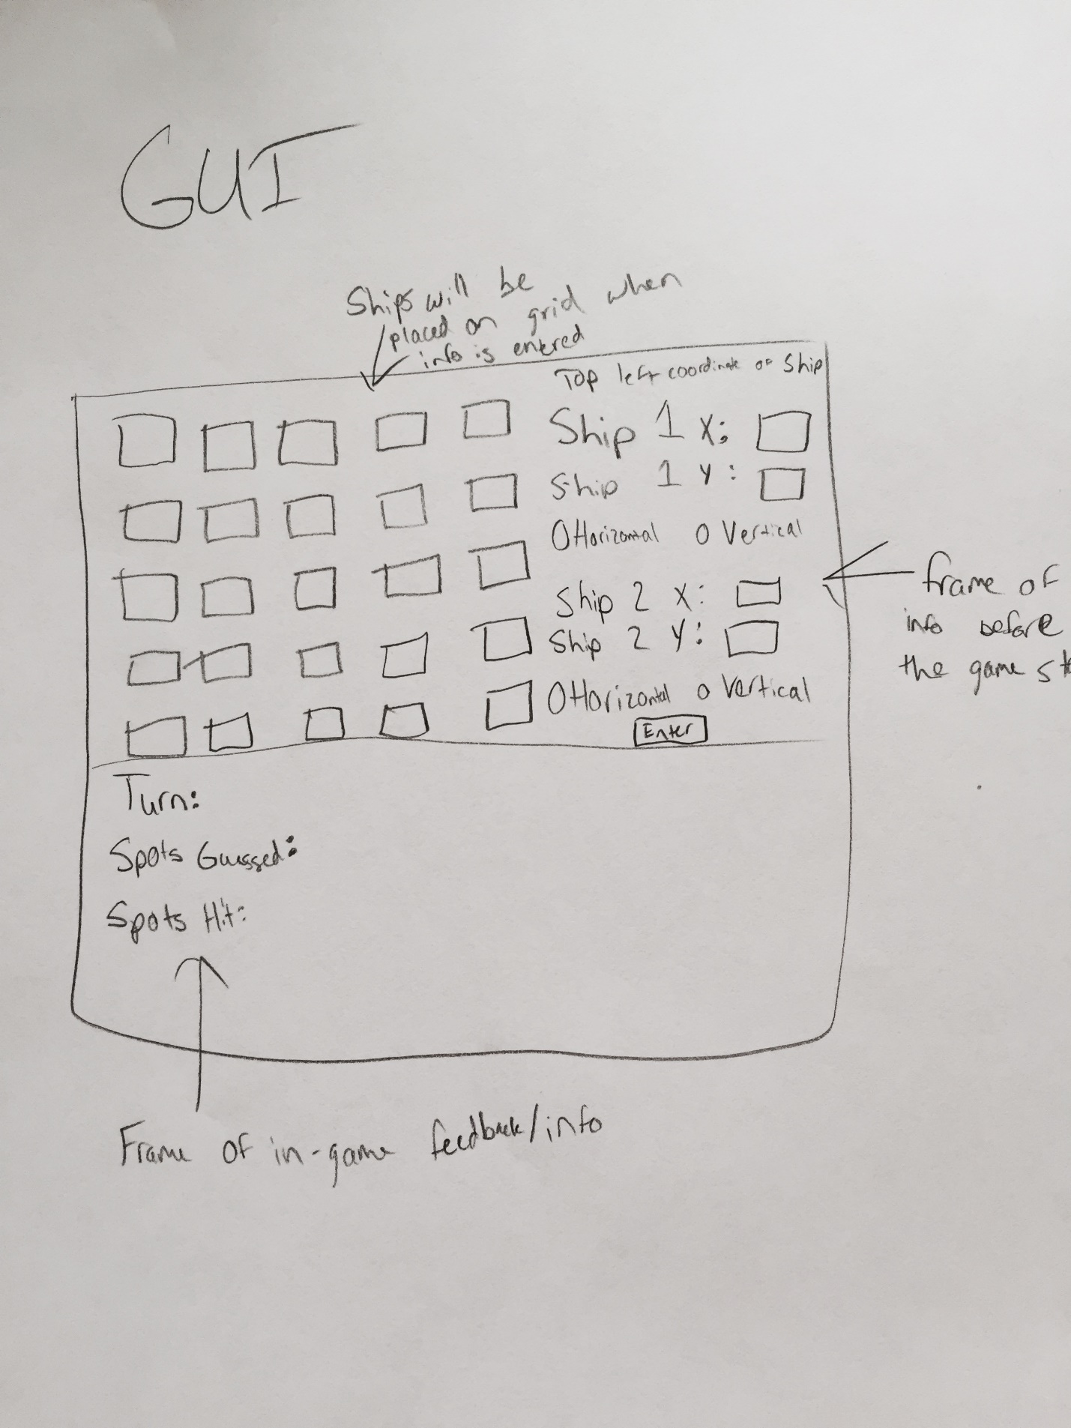

Canvas containing a five by five grid shown through squares
After information is entered, two ships will be created and placed
Frame containing four labels for the coordinates and 4 horizontal/vertical radio buttons to correctly place the ships
If possible, once the ships are placed, replace the frame with a new one to display hits, misses, previous guesses, and the winner.

Classes:
Ship:
Locations of all points on the ship
Bool value for its condition (sunk, floating)
What spots have been hit, what haven’t

To use the gameboard, I will create a list of the spots and give it a value of ‘1’ if it occupies part of a ship and a ‘0’ if it doesn’t.

There will also be a method for the computer AI (if it hits a spot, continue guessing around that area until the ship is sunk)

Other memory:
Spots already guessed for both the user and computer
Whose turn it is

What I will test- Correct creation of instance variables, try and excepts for the inputs from the user, no overlapping ships

