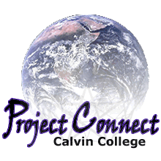
Computers at Garfield Park

If your family would like a computer but does not have one, Calvin College's Project Connect can help!
- It will teach you how to set up and use a computer.
- If you attend the training classes, you can keep the computer.
- Calvin College and Korean Grace Church will coordinate the classes.
- It’s free of charge (but space is limited).
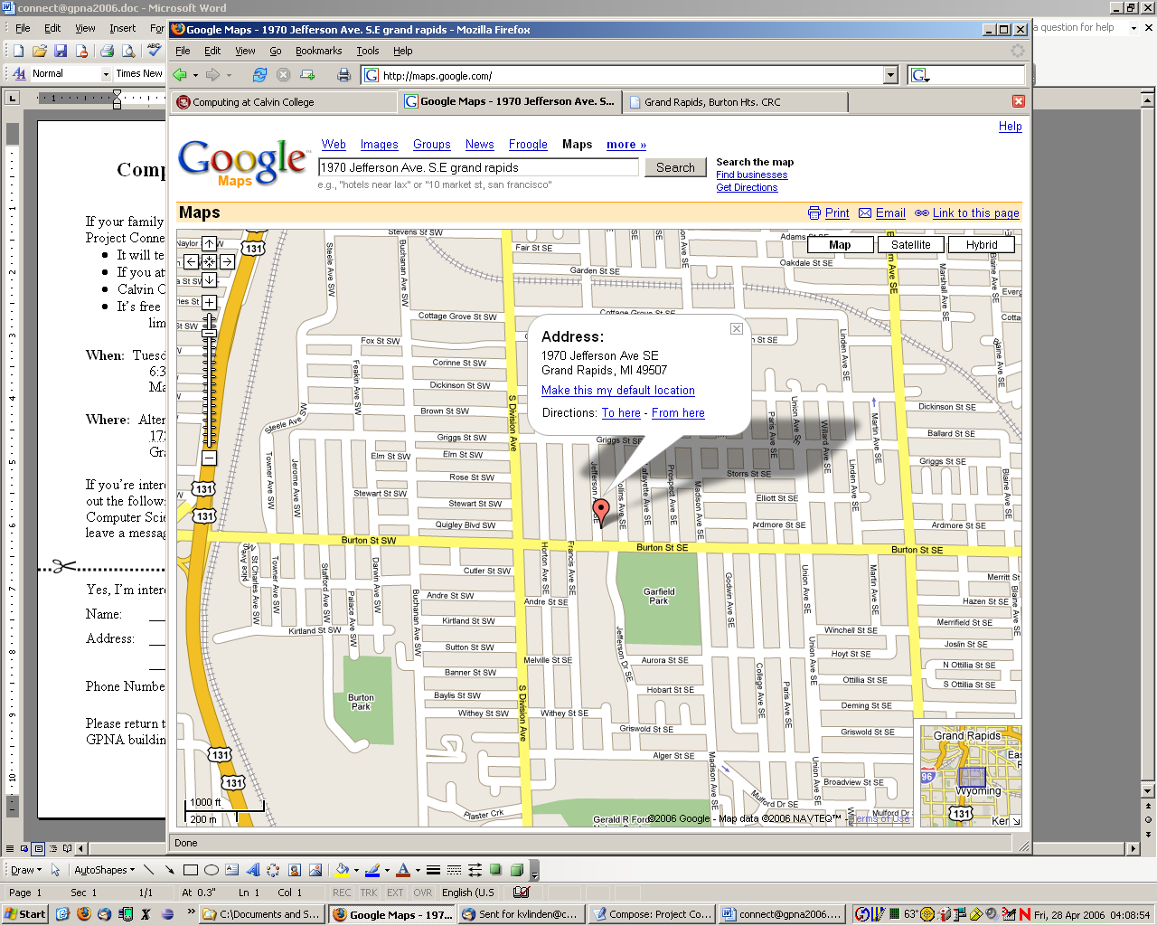
When: Tuesday & Thursday nights
6:30-8:30pm
May 29-June 7, 2007

Where: Korean Grace Church
1970 Jefferson Ave.
Grand Rapids, MI

If you’re interested, please detach and fill out the following form or call the Garfield Park Neighborhood Association and leave a message for Project Connect (241-2443).


Yes, I’m interested in Project Connect.

Name: _______________________________________
Address: _______________________________________
_______________________________________
Phone Number: ___________________________________

Please return this form to your Garfield Park Neighborhood contact, or to the GPNA building (334 Burton St). Thanks!

